**To Fly Exhibit App**

Kevin Deng, Cypress Bay High School

Dario Loriato, Cypress Bay High School

Sarah Valme, Hallandale High School

**Abstract**

Through weeks of content exploration and teamwork, our group was able to develop the To Fly exhibit app that seeks to solve simulator usage problems and provide a user-friendly way of communicating knowledge about aviation and aerodynamics to the visitors.

**Background**

In October 2014, the Museum of Discovery and Science offered its very first APP-titude internship, where high school juniors are able to participate in an immersion experience to learn about coding. Through this internship, all groups were able to explore the careers in STEM fields as well as meet influential mentors of the STEM fields. Furthermore, we were able to browse around the Museum of Discovery and Science and locate all the problems and small details that could be improved for visitors.

After exploring the museum, all three of us were extremely interested in the topics of aviation and aerodynamics. Thus, we chose the To Fly exhibit (formerly known as the Aviation Station) to create an app for and improve the visitor experience.

**Methods**

The first step in creating the To Fly app was to examine the exhibit and identify any problems or aspects that were missing to give the visitor a comprehensive experience about aviation. Our content exploration including visiting the museum various times and finding discussing the possible solutions that a mobile app can present for the problems we found. Such problems included guests being unable to operate the simulators, not reading the informational plaques and murals, and being lost in the museum. Our group divided the app development into three roles: java programming, graphics, and user interface. I (Kevin) became the java programmer because of my multiple years of java experience, Sarah accepted the role of creating a user-friendly interface and layout, and Dario became responsible for the graphic design of the app since he was also interested in art. Teamwork during the development process was essential to a successful app. At times, there were strong disagreements about how the appearance of the app or the content of the app. However, we all remained calm and discussed the pros and cons of each option and we were able to negotiate on each activity's graphical design as well content.

When we observed that guests were unable to operate the simulators, we decided to write out a step-by-step instruction page to incorporate in the app. In this way, visitors will be able to enjoy the fun of each aircraft simulation with no hassle. In addition to just the simulator instructions, we decided to provide an informational page in the style of a navigation drawer activity for each simulator. The informational plaques on the wall are often overlooked by guests; therefore, the interactive pages of the app will introduce a clearer and user-friendly way for visitors to learn about the history and features of each simulator aircraft. Moreover, we also decided to include a Fun Facts page in a swipe-view interactive page to provide a fun and simple way for users to learn about random, interesting facts about the history and science of aviation and aerodynamics.

Our goal of this app was to make it appealing for both children and adults; it had to be educational, but not boring. Days of brainstorming led us to one of the best ways to help visitors learn through a simple, interactive, and fun experience: a trivia quiz game. With the trivia quiz game, users will be able to participate in an interactive ten-question multiple choice quiz with aesthetic yet simple graphics. At the end of this quiz, the correct answer as well as additional information on the subject is provided to further increase the user's knowledge.

Finally, to improve the user's overall museum experience, we decided to include a map of the museum, highlighting the area that they are in currently. This will minimize the amount of visitors that become lost in the museum or don't know where other exhibits are.

**Results**

Through weeks of content exploration and a total of nine full days at FAU, we were able to successfully complete a first version of the To Fly exhibit app. The main screen features a rocket background with main categories/buttons: Simulators, Games, Fun Facts, Parts, and Map. The Simulators button features a very easy-to-use navigation menu with the Simulator Instructions as the first page. Users are able to navigate through the menu to select a specific simulator or attraction. A page with a photo and information on the history and features of each unique aircraft will be displayed.

The Games button loads a popup to select the Trivia Quiz Game. Users are able to interactively participate in aviation and aerodynamic related trivia game to test their knowledge of flying. Answers with a full explanation and additional information are displayed at the end of the engaging quiz.

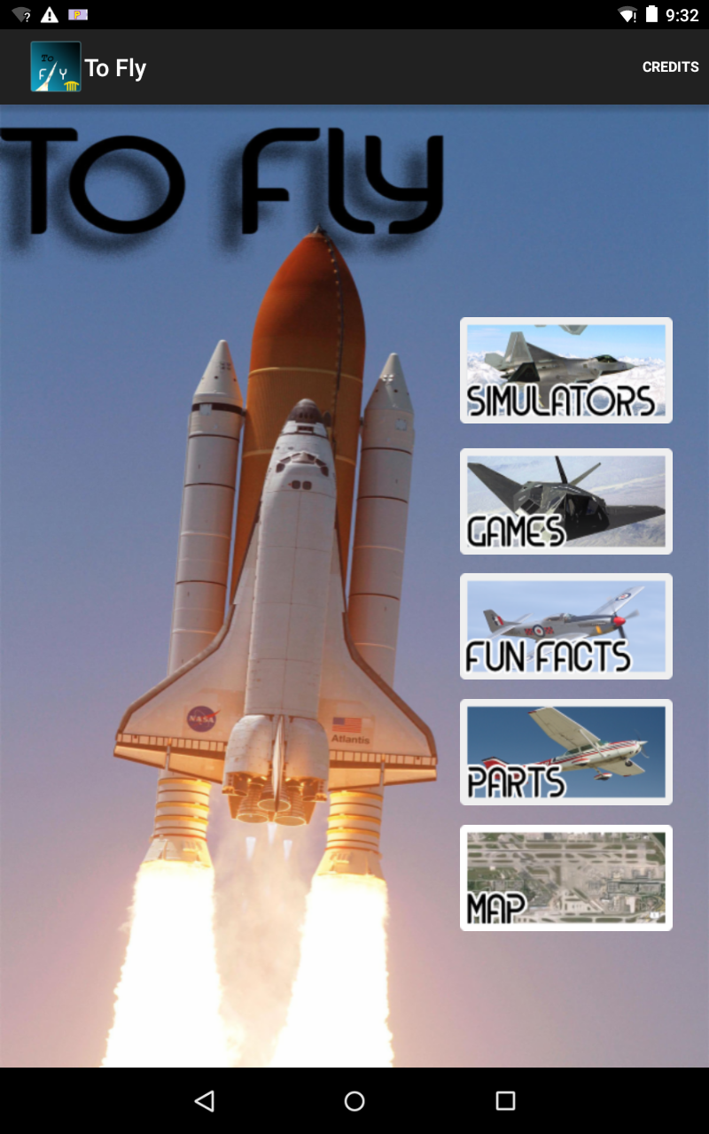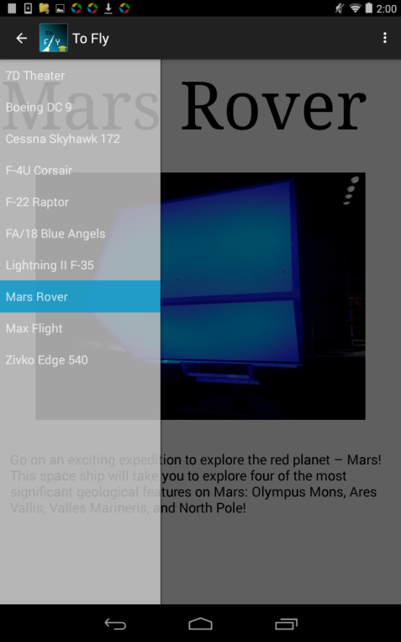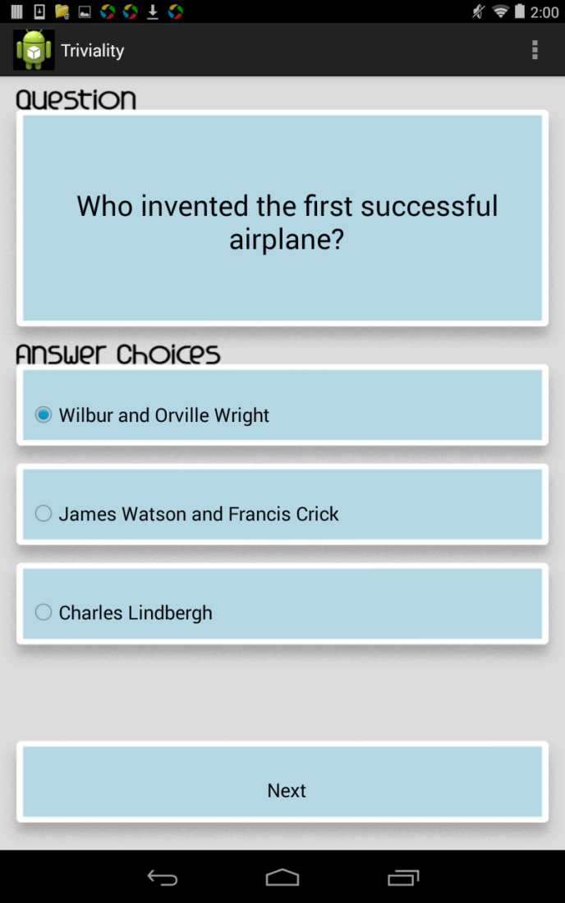

The Fun Facts page presents a very user-friendly swipe view activity in which visitors are able to swipe through the screen for various and random fun facts. These interesting "did you know" facts certainly grasp the user's attention as most of them are pretty unusual.

The Plane Parts category is probably the most comprehensive and informative activity of the app. Through a graphical perspective, the plane blueprint background of the page gives the user an "engineer" feel. The main page features three subcategories: body, materials, and control. The "Body" button loads a tabbed activity in which visitors can swipe through the page to learn the functions of each part of the body of a plane, such as the cockpit, landing gear, engines, etc. The Materials page lists and describes the different types of materials, such as aluminum and steel, and compares the pros and cons of how each material affects the airplane. The Control button will lead to a descriptive page on the function of the control tower, as it is usually overlooked. We stress the importance of the control tower because it is truly the heart and soul of air traffic safety around the world.

Lastly, the Map button loads the map of the MODS Explorer app. In the map, the user can click the second floor and click the To Fly exhibit, which will load the To Fly app again.

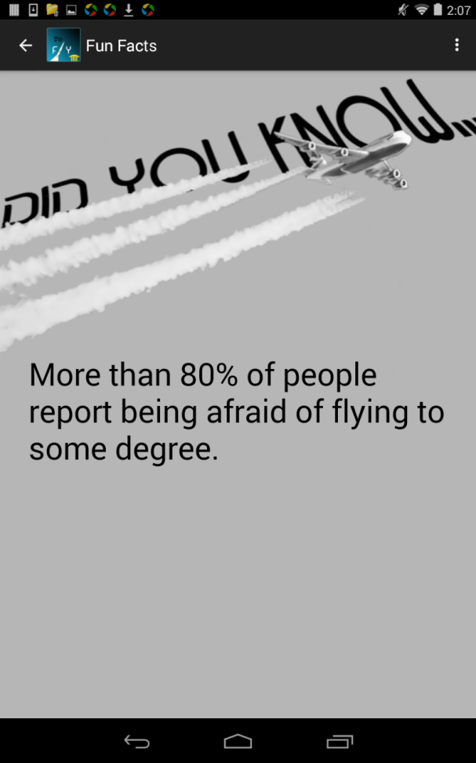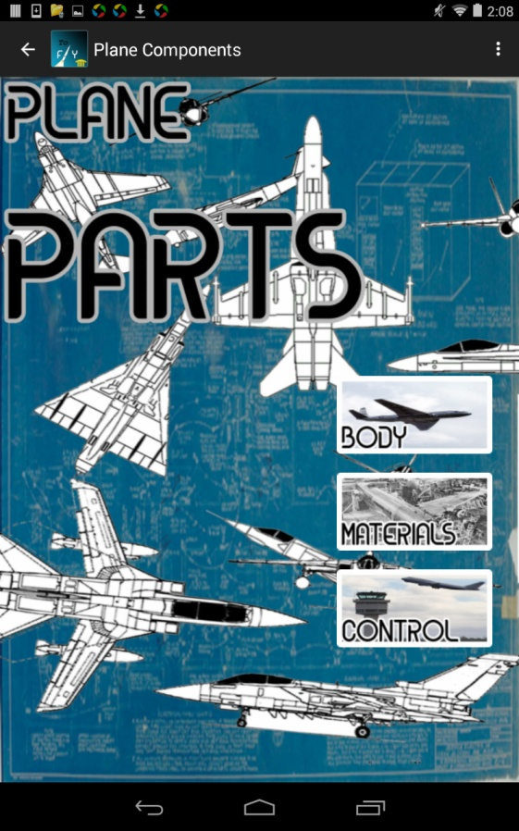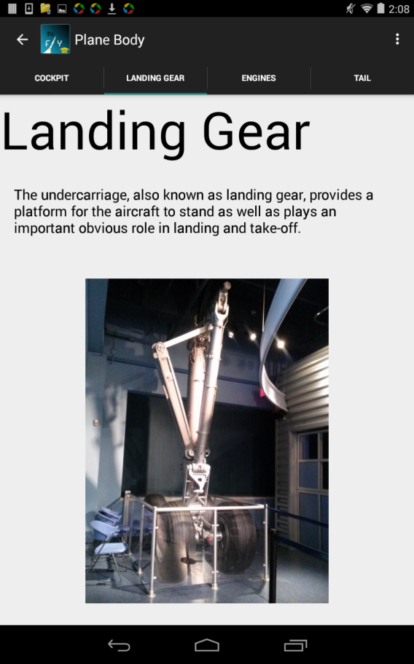

**Discussion**

Although the majority of the app has been completed, there is much improvement to be made in the future. One such improvement could be the addition of a scavenger hunt game, in which users will answer specific questions that are directly answered in the exhibit itself. The graphics of the informational pages of the simulators and plane parts can also be worked on to create a more eye-appealing app overall. Sound effects and visuals are also on the list of future developments. In order to make this a complete app, the app should be linked to a main MODS app so that the To Fly exhibit app can be accessed directly from the main MODS app.

**Conclusions**

After three weeks of hard work, determination, and sometimes tears, the final product of this app is one of our prized possessions yet. It is our first app ever created and we are all proud of it as well as the process we had to endure through. Android Studio and even GitHub were not the easiest applications to use. At times, many things went wrong and opposite of our expectations. However, with a positive mindset and determined mentality, we kept our composure and embraced the challenges. The fast-paced engineering course at FAU relied heavily on at-home efforts and team communication. In the final stretch, the knowledge, cooperation skills, and professional experience will have a lifelong impact on all of us. This experience has definitely shaped us into professional, mature students ready to take on the experiences in the real world.

All versions of the To Fly app can be found on the open source GitHub at this link: https://github.com/MODSApps/To-Fly-App. The final app is located in the Project-Assignment-3 Folder. Please read the readme.md file before downloading.

**Acknowledgements/Credits**

We would like to thank the following FAU staff and Museum of Discovery and Science organizers:

Dr. Shankar

Professor McAfee

Santiago Aguerrevere

Demetrius Dukes

Alain Edwards

Dr. Mitsova-Bonevac

Summer Scarlatelli

Joe Cytacki

In addition, we would like to thank the United Way of Broward County for donating the grant for the APP-titude Internship program.

Other acknowledgements include our schools, Cypress Bay and Hallandale High School, as well the authors of the textbooks we used, Paul Deitel, Harvey Deitel, Abbey Deitel, and Neil Smyth.

Without your endless support and efforts, this app would not have been made possible. From the bottom of our hearts, thank you so much!

**References**

The following references were the key to success of this project:

GitHub

Android Studio

Nexus 7 Tablet

*Android Development Essentials* by Neil Smyth

*Android for Programmers: An App-Driven Approach* by Paul, Harvey, and Abbey Deitel

Photoshop

StackOverflow Forums